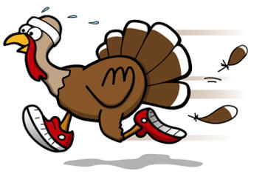

Chip Timed,   
Awards & Door Prizes

400 meter Kids Dash  
5K Run/Walk

**Schedule of Events**

**Wednesday, November 27** – Early packet pick-up, **6 PM-7:30 PM**  
 •Avoid the rush on race day by picking up your race packet the night before!  
**Thursday, November 28** – Race Day!  
 •**7:30 AM**-Race day registration & packet pick-up  
 •**8:30 AM**- Kids Dash (400 meters, RHS Track)  
 •**9:00 AM**- 5K Run/Walk

Follow us on Facebook or email turkeytrot4tots@hotmail.com for more information/event updates.  
Online registration available at https://runsignup.com/Race/IL/Robinson/RHSAlumniTurkeyTrotforTots

Thanksgiving Day • Thursday, November 28th, 2019  
Robinson High School • 2000 N. Cross Street • Robinson, IL

Registration Form

Name: ___________________________________________________________________________________________________

Address: ________________________________________ City: ____________________________ State: _____ Zip: __________

Phone: _______________________ Email: ______________________________________________________ Age: ___________

Sex: F or M Event: Kids Dash or 5K Run/Walk

Shirt size: YS YM YL YXL S M L XL 2X 3X

Long sleeved, cotton t-shirts free for participants registered by **November 13, 2019.** Shirts can be ordered from Nov 14th to Nov 28th for an additional $10.00 per shirt. This order will not be placed until the 29th of Nov.Entry fee, $20.00 per participant

Payment method: ____ Cash ____Check

Make checks payable to ***Robinson Fire Department*** and mail to:   
Robinson Fire Department • ATTN: Turkey Trot for Tots • 400 S. Jackson St. • Robinson, IL 62454

WAIVER  
In submitting this entry, I, intending to be legally bound for, my heirs, executors and administrators waive, release and forever discharge any and all rights and claims that I may hereafter accrue to me again any of the even sponsors, event directors, event volunteers, agents, successors and/or assigns for any and all injuries suffered by my family and I at this event, while traveling to and from the RHS Alumni Turkey Trot for Tots or while participating in the event. I attest and verify that I am physically fit and sufficiently trained for competing in this event.

Signed:______________________________________________________________________________________________________________  
 (Parent/Guardian for those under the age of 18)

11th Annual  
RHS Alumni Turkey Trot for Tots